Modelling, Simulation and Optimisation

Motorway” as a possible approach to reduce congestion on motorways. Your task is to replicate aspects of this research using a simulation model implemented in SimPy v.4.

Create a simulation for a 3km segment of motorway that reduces after 2km from 3 lanes to 2 lanes, as shown below on a screen shot from the TCD website.

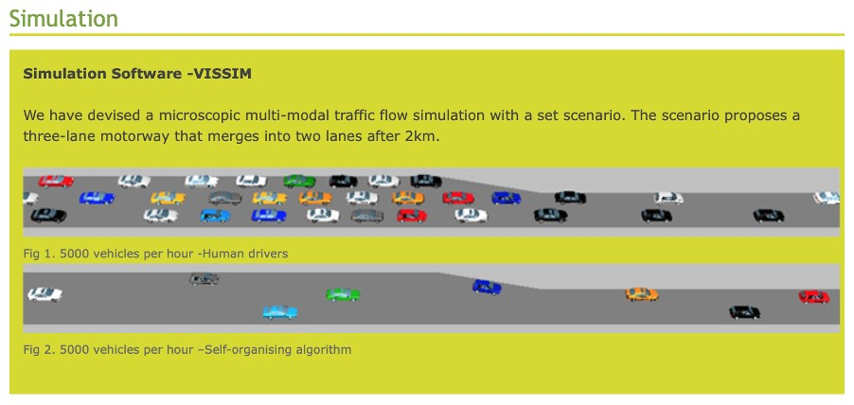

Answer the following questions:

- What is the as optimal average traveling time t_{opt} in free flowing, non-congested traffic?
- What is the optimum throughput N_{opt} in cars/hours when the average traveling time is 20% longer than t_{opt}. (The Trinity Study seems to indicate a value of N_{opt}=4000 cars/hours, see Fig.2 below)
- What is the maximum throughput N_{cong} in cars/hours when the motorway is heavily congested, but the traffic is still flowing? We define traffic as congested, when the average travelling time t_{cong} is twice the optimal average travelling time t_{opt}. (The Trinity study seems to indicate a value of N_{cong}=5000 cars/hours, see Fig.2 below)

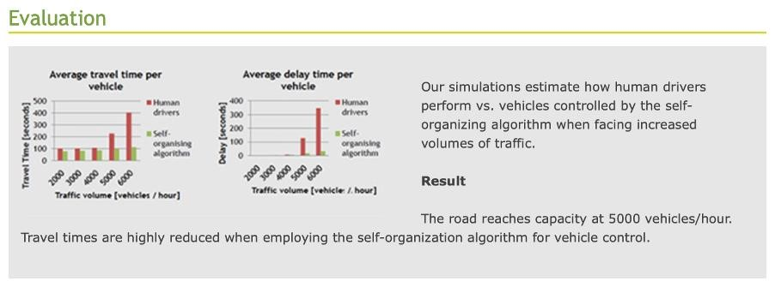

Figure 2: Simulation Results as shown on the TCD Project Website

Note: The travelling time t_{opt} and t_{cong} as well as the throughput figures N_{opt} and N_{cong} depend of course on your assumptions about the traffic mix, i.e. the distribution of vehicle types and drivers behaviour that you have considered as given. Make sure that you clearly document your assumptions.

We are facing two major changes:
- An increase in the number of fully electrical vehicles (with a different acceleration / deceleration factors), and
- An increase in the number of autonomous or partially automated cars (both electrical and conventional) following an improved driving strategy.

The aim of the simulation study is to investigate the influence of these two parameters on
Nopt and Ncong.

You may use components from the Motorway Simulation Study presented in class. When reusing code or design elements, refer to the version uploaded on Moodle.

Deliverables
The project has two deliverables:

- A final report in .pdf format describing your simulation study should have maximal 6 pages in IEEE conference format and follow the outline structure given below

- A .zip file with the code as (one or more) Jupyter Notebook files and any additional data files and documentation that may be required. Each Jupyter Notebook file (in .ipynb format) should be accompanied by a text document (in .pdf format) that describes the Notebook file.

The final report will be uploaded through the Turn-it-in link provided on Moodle.

For evaluation criteria please check the Rubrics given at the end of this project outline.

The Structure of the Final Report
Abstract with Keywords
- Introduction
In this section you introduce the problem you intend to investigate and articulate the research question you intend to answer.

- Literature Review
To the extend you have referred to the literature for model parameters give a summary of your sources and the parameter values you have extracted. When you refer to data provided in class use as reference the material provided on Moodle.

- Methodology
Describe the sequence and possibly intermediate stages of your development and give references to the relevant section of code in the Jupyter Notebook file.

- The Simulation Model
This section should give a clear description of the key components of the simulation model. There is an interaction between vehicle types, driver behaviour and the overall traffic generation model. Explain the choices you have made. When your study is based on particular parameter settings include them clearly readable in tabular format. Subsections should cover the following aspects:

  - Model for vehicles
  - Model for the behaviour of human drivers
  - Model for autonomous or computer assisted driving
  - Model for the Motorway section
  - Model for Traffic Generation
  - Data Collection

- Results and Interpretation
Report the results of your simulation study and give an interpretation of the same. In particular check if your results are consistent with data published in the literature and/or common sense. Should there be major deviations, discuss possible reasons for the same.

- Conclusions and Future Work
Discuss how your research could be improved and suggest problems for future research.

- References

